# JS Advanced - Retake Exam

Problems for exam preparation for the [“JavaScript Advanced” course @ SoftUni](https://softuni.bg/courses/javascript-advanced). Submit your solutions in the SoftUni judge system at <https://judge.softuni.bg/Contests/TODO/>.

# Problem 1. Coffee Bill

Use the given **resources** to solve this problem. You have **NO permission** to directly change the given HTML code (index.html file).

### Your Task

**Write the missing JavaScript function** addProduct() to make the **[**Add**]** button work as expected - when clicked **adds** the new product’s information to the restaurant bill. The **[**Add**]** button should:

* **Append** the **text** received from the **input boxes** as a **new** **row at the end** of the **table’s body**
* **Add** the **new** **product’s price** to the **total** sum
  + Thepriceshouldbe **bigger than 0**
* **Clear** the **input boxes** after the **product’s information** is **submitted**
* **Do nothing** if **either** of **text boxes** is **empty**

### Examples

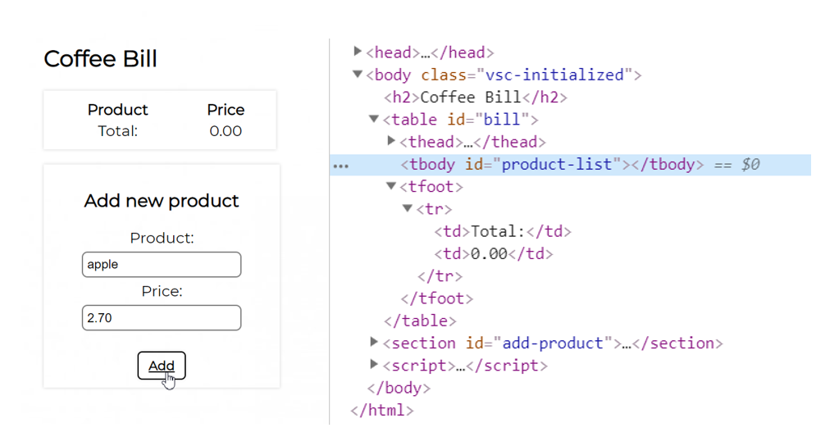

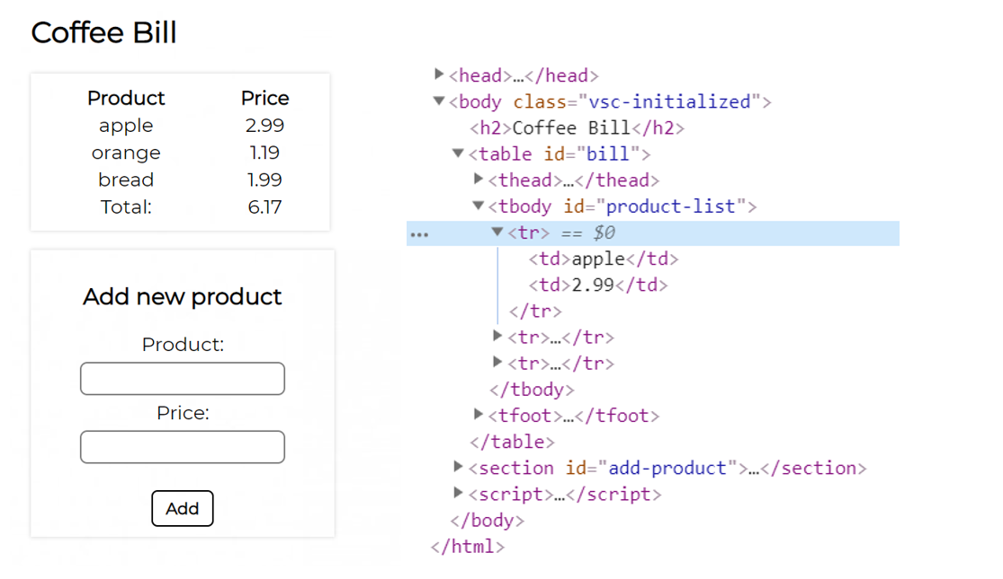

### Submission

Submit only your addProduct() function.